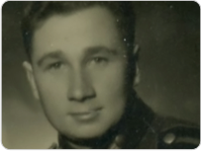
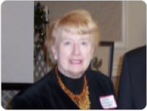
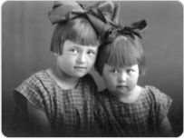
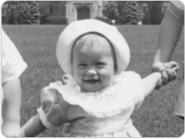
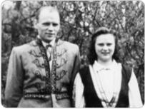
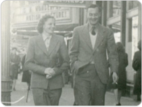


Shot 1: Peter Green nee

Audio: “I am Canadian”

Shot 2: Ausma Berzgalis in 2005

Audio: “Home”

Shot 3: Mirdza and Valda Grivnieks 1928

Audio: “Outer skin”

Shot 4: Viola Baker & Husband in Canada

Audio: “Canadian Winter”

Shot 5: Regina and Zorzs Čaks in Latvia

Audio: “Free”

Shot 6: Maija McLeod nee Poruks

Audio: “Canada is my home”

